Weather Trend Forecasting Using Global Weather Data

Prepared by: Chinta Tharun Kumar

PM Accelerator Mission
PM Accelerator is an organization founded by Dr. Nancy Li that helps aspiring and experienced professionals build successful careers in product management. Its main mission is to make product management education and career opportunities more accessible to people from different backgrounds. The organization helps individuals develop practical skills, prepare for interviews, build professional portfolios, and become confident product leaders. PM Accelerator provides training, mentorship, career coaching, and hands-on learning opportunities. It also supports professionals who want to transition into product management or advance their existing careers.
The organization also promotes equal access to education through its PMA Kids initiative, which focuses on providing free product management education to teenagers from underserved families.

Objectives
The main objective of this project is to analyze global weather data and forecast future weather trends using Python and machine learning techniques. The project focuses on understanding weather patterns and relationships between temperature, humidity, precipitation, wind speed, and air quality. The first objective is to clean and prepare the dataset by handling missing values, identifying outliers, and normalizing numerical features. Exploratory Data Analysis (EDA) is performed to identify important weather trends and correlations through visualizations. The project also aims to detect unusual weather conditions, study climate variations across different countries, analyze air quality, and identify important weather features. Another objective is to develop and compare forecasting models, including ARIMA, Random Forest, and an ensemble model. Their performance will be evaluated using MAE, RMSE, and R². Finally, the project aims to present meaningful insights through clear visualizations and observations while improving practical data analysis and machine learning skills.

Dataset Overview
I used the Global Weather Repository dataset from Kaggle for this project. The dataset contains 170,928 rows and 41 columns. It includes weather information from different countries, such as temperature, humidity, rainfall, wind speed, air quality, and location. I used Python in Google Colab to analyze the dataset

Data Cleaning and Preprocessing
Before analyzing the weather data, I checked the dataset for missing values, duplicate records, and unusual values. I handled invalid air quality values and used the median to fill missing numerical values where needed. I also checked for temperature outliers using the Interquartile Range (IQR) method. Next, I converted the date column into a proper date format and created additional features such as year, month, and day. I used Standard Scaler to normalize the numerical features.

My Observations
After cleaning, the dataset contained 170,928 rows and 44 columns, with no remaining missing values.
The IQR method identified 3,125 temperature outliers. I kept these observations because they could be useful for detecting unusual weather conditions in later analyses.
The dataset was ready for further analysis and modeling.

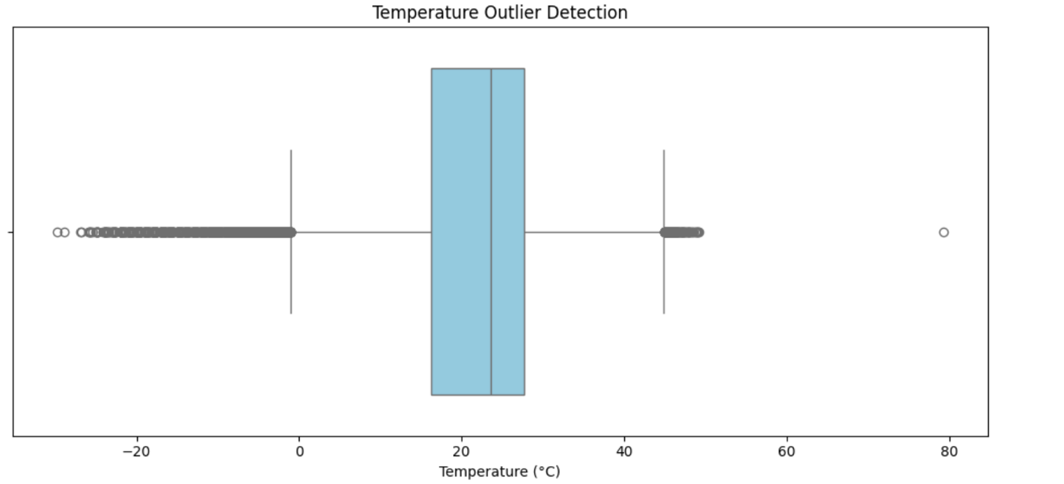

Exploratory Data Analysis (EDA)
I performed Exploratory Data Analysis (EDA) to understand weather patterns and relationships between different weather variables. I used Python libraries such as Matplotlib and Seaborn to create visualizations of temperature, precipitation, humidity, and other weather conditions. The analysis included temperature distribution, precipitation distribution, temperature versus humidity, and a correlation heatmap to identify relationships between weather features.
My Observations:
I observed that most temperatures range between 15°C and 30°C. The highest frequency is around 25°C to 30°C. Extreme temperatures are less common.
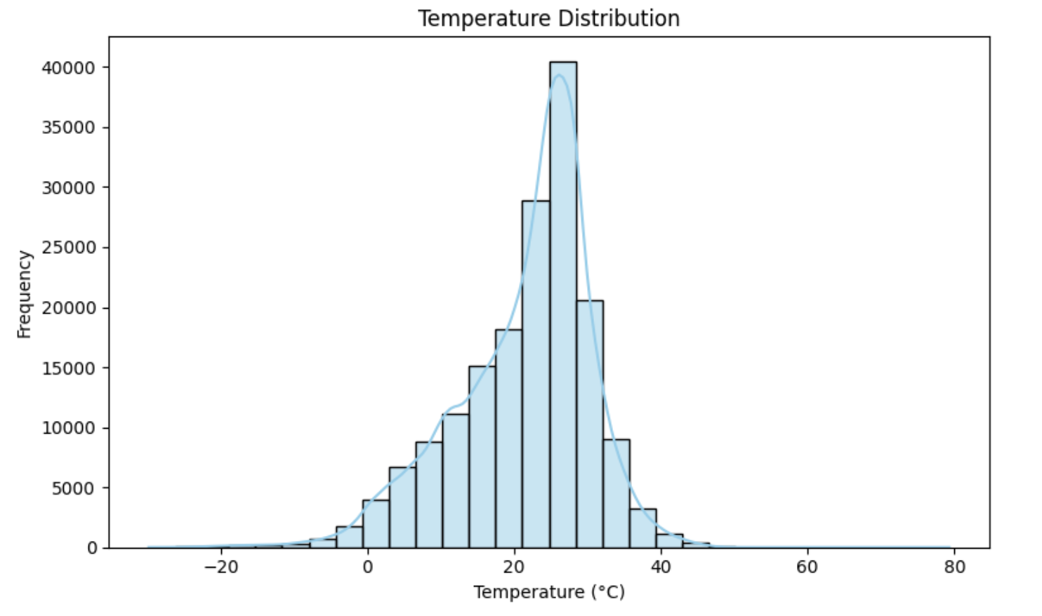
My Observations:
Most precipitation values are close to 0 mm, indicating little or no rainfall. A few values reach approximately 75 mm. This shows that heavy rainfall is less common.
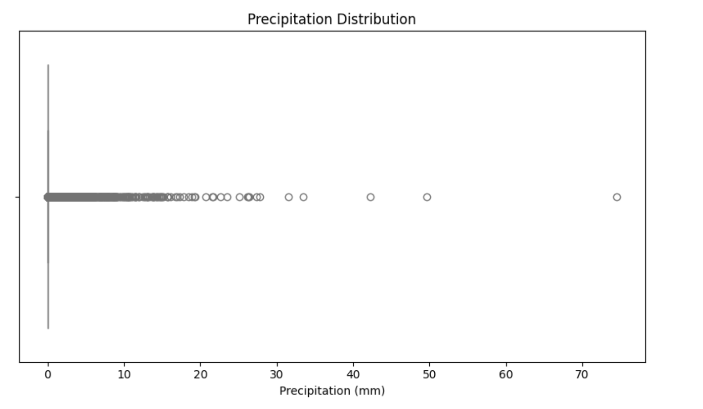
My Observations
I observed that humidity generally decreases as temperature increases. However, humidity varies even at similar temperatures. This shows a moderate negative relationship.
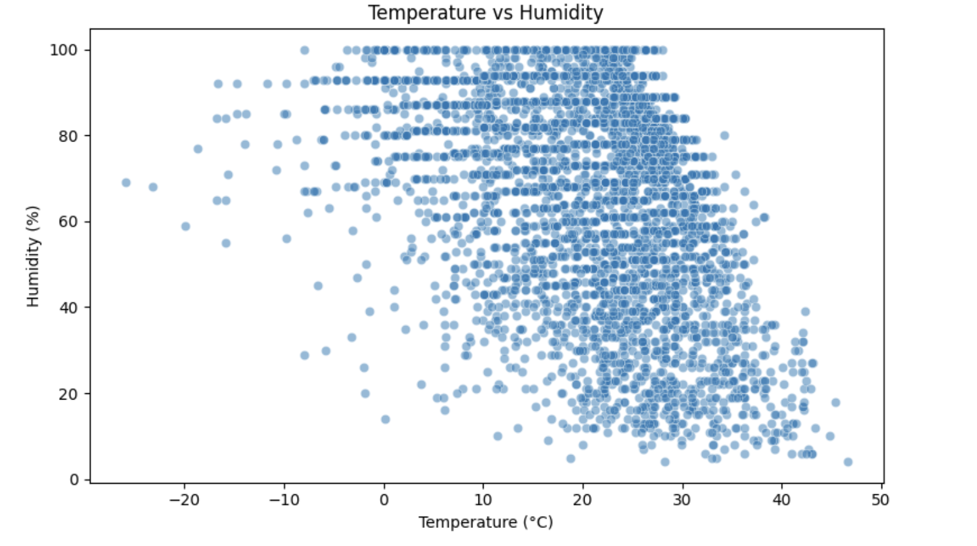
My Observation:
Temperature is positively correlated with UV index (0.48) and negatively correlated with humidity (-0.34). Humidity is positively correlated with cloud cover (0.50). These relationships help identify important weather patterns.

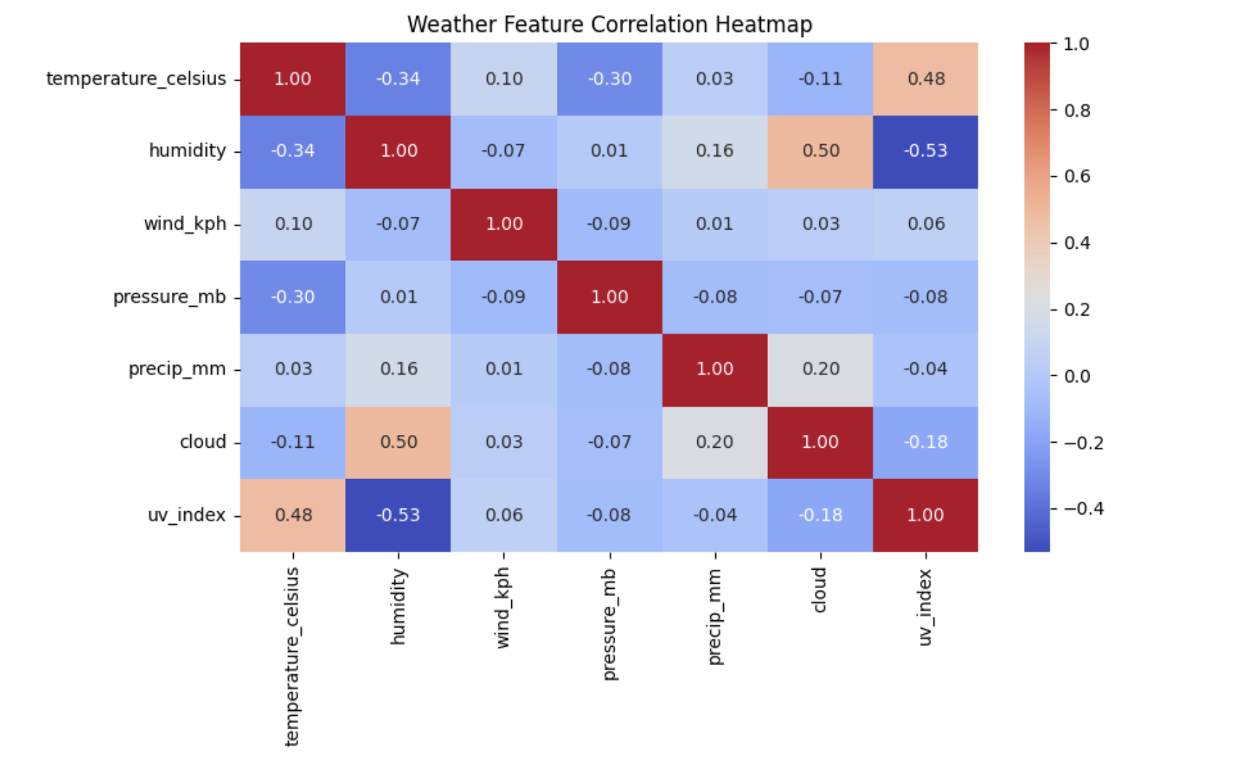

Advanced EDA – Anomaly Detection
I used the Isolation Forest algorithm to identify unusual weather observations based on temperature, humidity, wind speed, atmospheric pressure, and precipitation.
The model detected 1,710 anomalies out of 170,928 weather observations.

My Observations
I observed that most weather observations were classified as normal.
The model identified 1,710 unusual observations, approximately 1% of the dataset.
These anomalies may represent extreme or uncommon weather conditions that require further investigation.
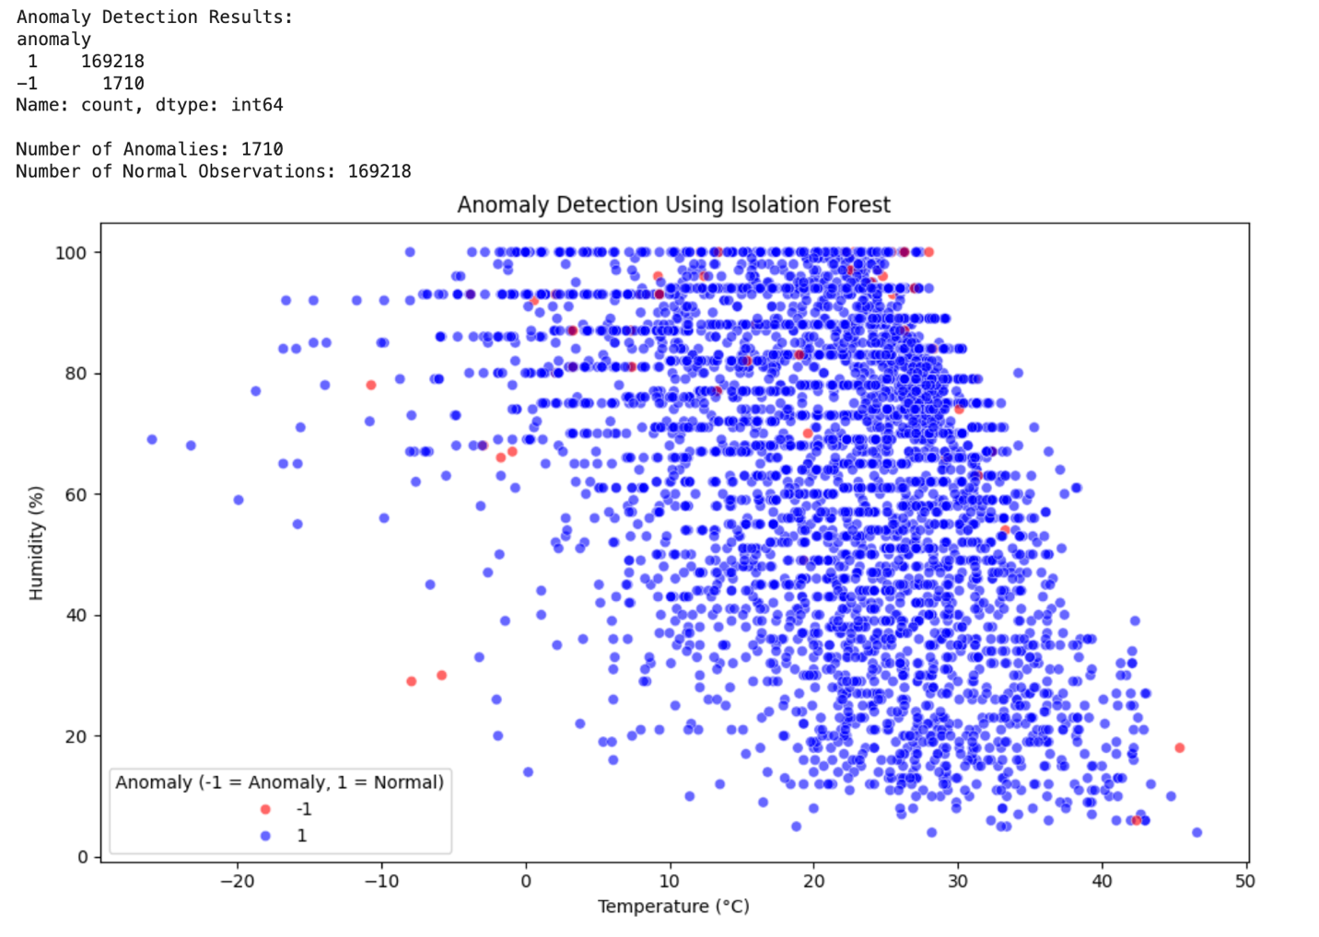

Climate Analysis
I performed climate analysis to understand temperature patterns across different months and countries. I calculated monthly average temperatures and identified the countries with the highest average temperatures.
- Monthly Average Temperature
My Observations
I observed that average temperatures increase from January to July, reaching approximately 25°C. Temperatures then gradually decrease toward December. This shows a seasonal pattern in the dataset.
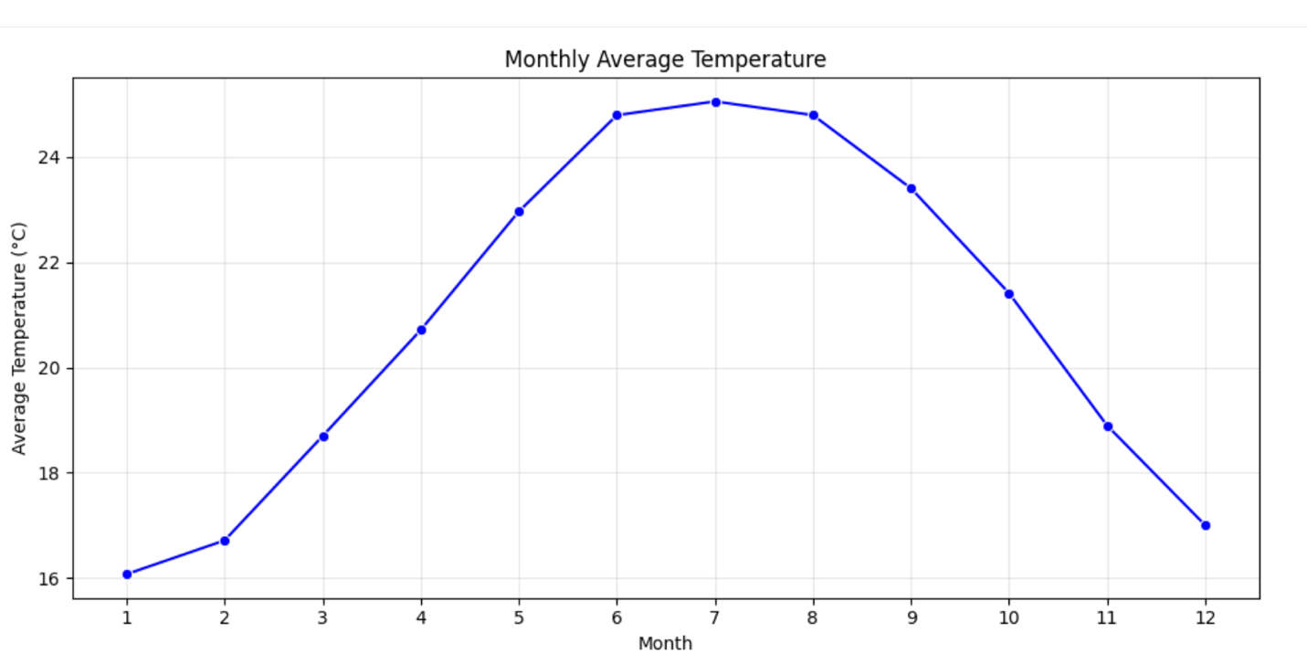
- Top 10 Hottest Countries
My Observations: I observed that the average temperatures vary across countries. Qatar, the United Arab Emirates, and Oman appear among the countries with higher average temperatures. This highlights geographical differences in weather conditions.
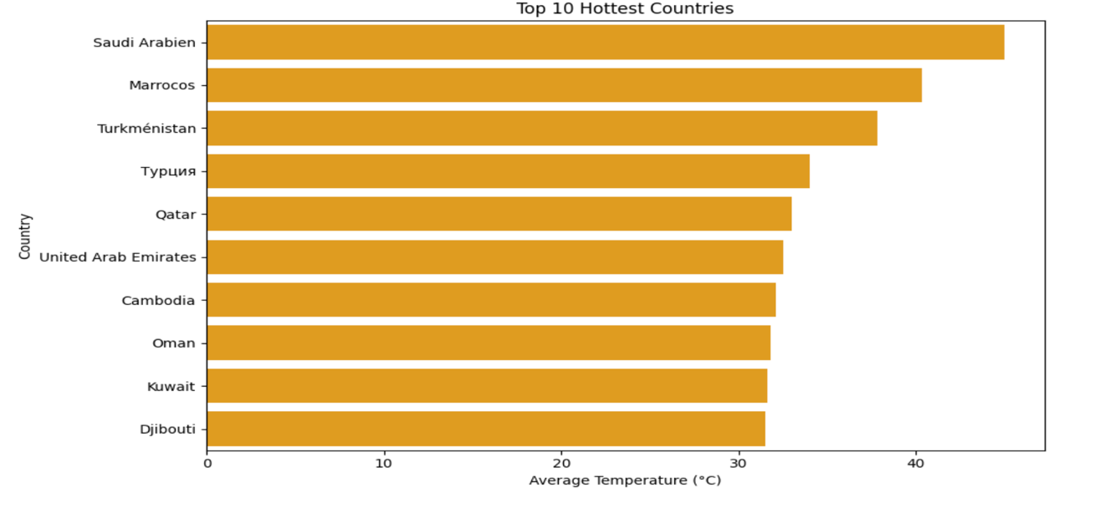

Geographical Pattern Analysis
I performed geographical pattern analysis to understand how temperatures vary across different countries. I calculated the average temperature for each country and compared the ten countries with the highest recorded averages.

My Observations
I observed that average temperatures differ across countries.
Qatar, the United Arab Emirates, and Oman showed relatively high average temperatures.
These highlights geographical variations in weather conditions across the dataset.
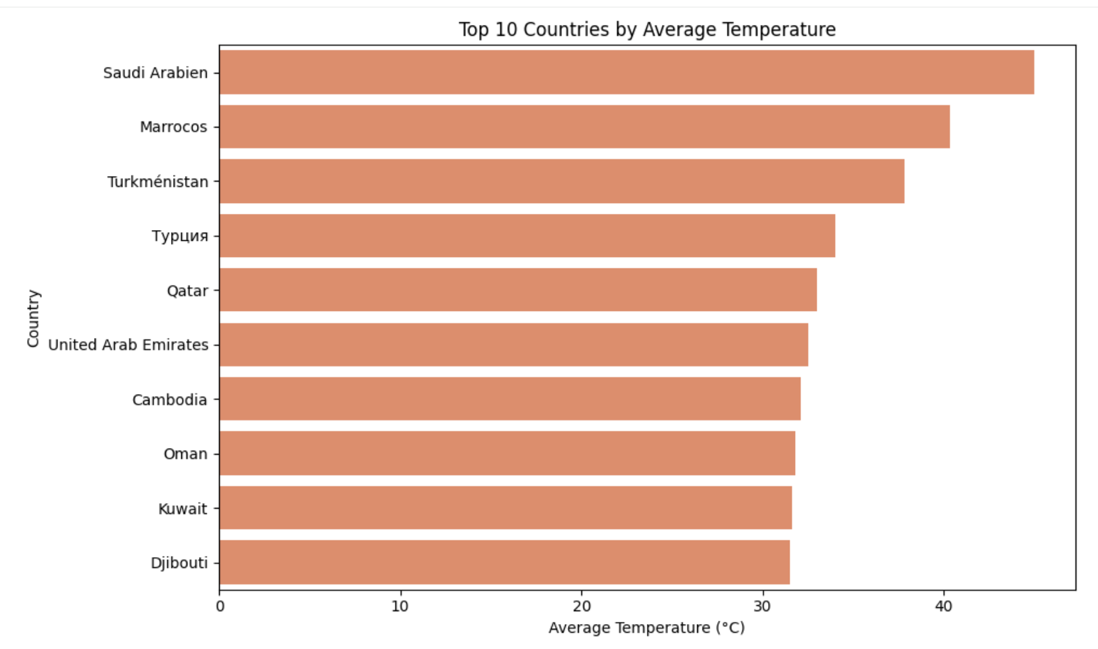
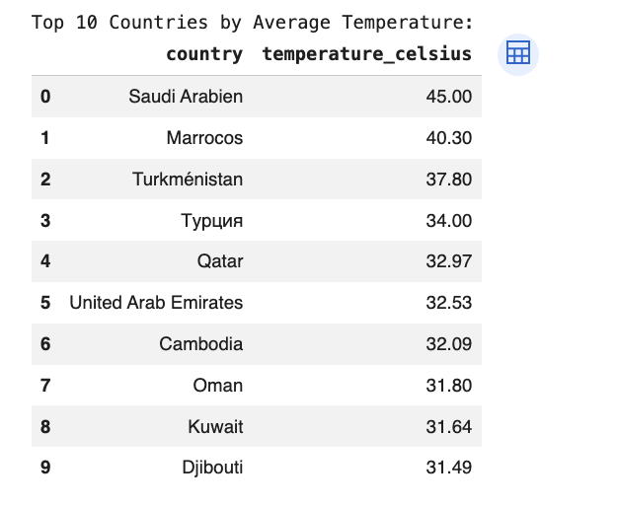

Environmental Impact Analysis
I performed environmental impact analysis to understand the relationship between air quality and weather conditions. I used a correlation heatmap to compare PM2.5, PM10, temperature, humidity, and wind speed.

My Observations
I observed a strong positive correlation (0.66) between PM2.5 and PM10.
Humidity showed a weak negative correlation with PM2.5 (-0.22) and PM10 (-0.24).
Temperature and wind speed showed weak correlations with air pollution levels.
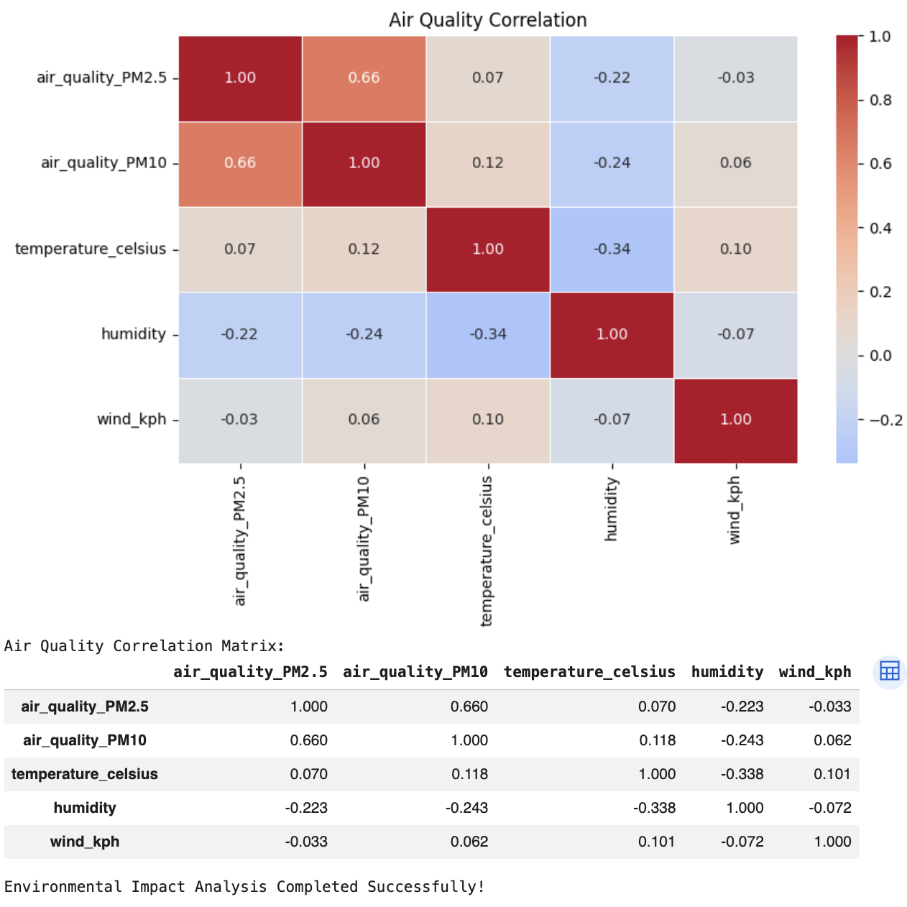

Feature Importance Analysis
I used the Random Forest Regressor to analyze which weather factors are most important for predicting temperature. The analysis included humidity, wind speed, atmospheric pressure, cloud cover, UV index, and precipitation.
Feature importance scores were calculated and visualized using a bar chart to compare the contribution of each variable.

My Observations
The feature importance chart shows which weather variables contribute most to the model's temperature predictions. Features with higher importance scores have a greater influence on the model's predictions.
This analysis helps identify useful weather variables for temperature prediction.

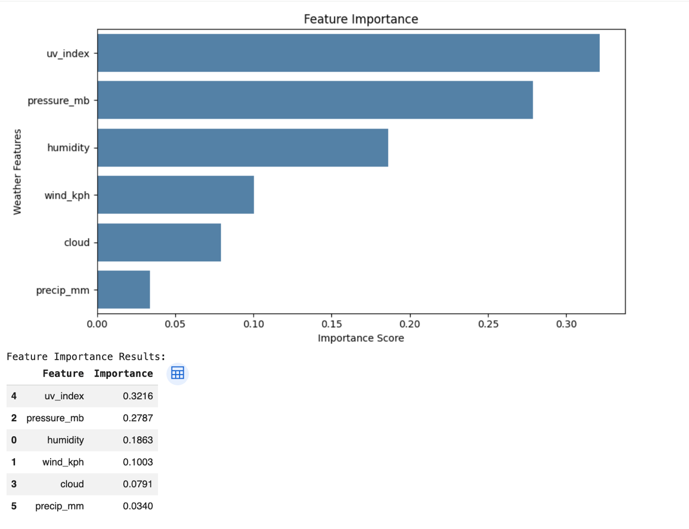

Spatial Analysis
I performed spatial analysis to visualize the geographical distribution of weather observations across different locations worldwide. I used Cartopy and Matplotlib in Python to visualize weather observations on a world map using latitude and longitude coordinates.
The map displays weather observation locations and their corresponding temperatures, helping to understand geographical variations in weather conditions.

My Observations
The map shows weather observations from different locations around the world.
Temperatures vary across geographical regions, highlighting differences in local weather conditions.
This visualization helps identify spatial patterns and compare weather conditions across locations.
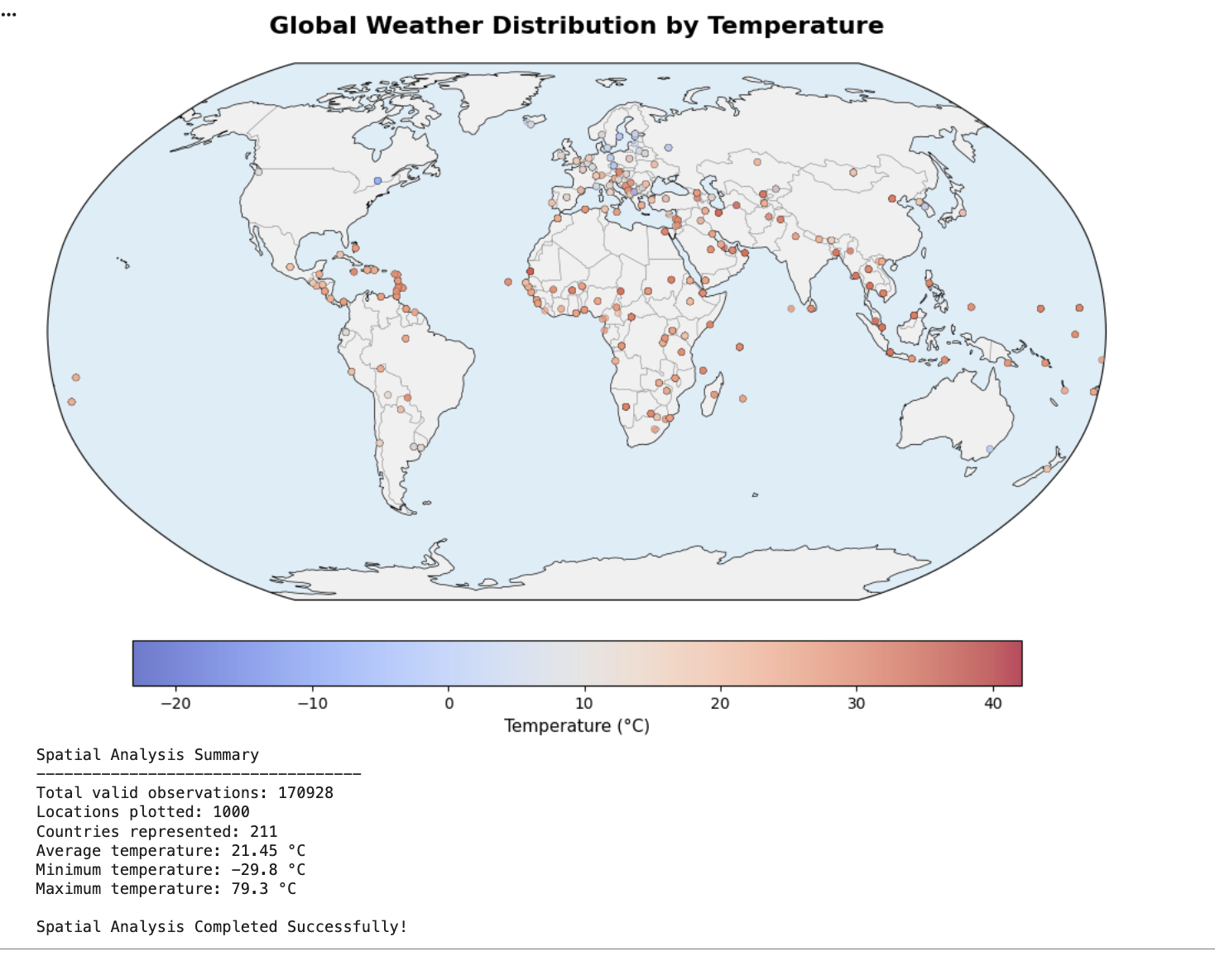

Model Building and Forecasting
I used the last updated column to organize weather observations by date and calculate daily average temperatures for time-series forecasting.
I selected three forecasting approaches: ARIMA, Random Forest, and an Ensemble model combining their predictions. These models were chosen to compare traditional time-series forecasting with machine learning. To evaluate model performance, I used Mean Absolute Error (MAE), Root Mean Squared Error (RMSE), and R². Lower MAE and RMSE values indicate better prediction accuracy, while higher R² values indicate better model performance.

My Observations
Random Forest achieved the lowest RMSE among the three forecasting models. Actual temperatures fluctuated over time, while the forecasted temperatures remained relatively stable. This suggests that the models struggled to capture short-term temperature changes accurately.

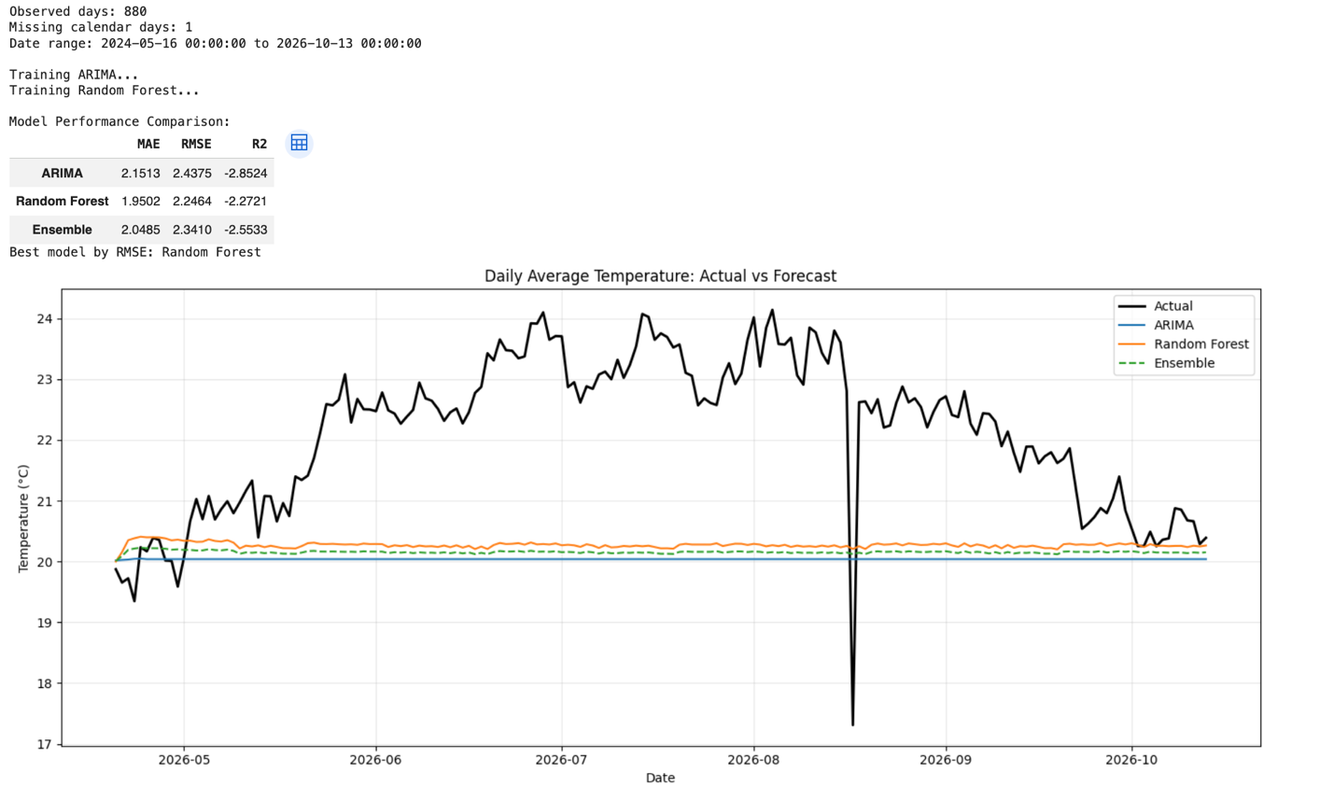

Conclusion
This project helped me understand global weather patterns using data analysis, visualization, and machine learning techniques. I analyzed temperature, precipitation, humidity, air quality, and geographical differences across various countries.
Through data cleaning, exploratory data analysis, and anomaly detection, I identified important weather patterns and unusual observations. Climate and environmental analyses provided additional insights into temperature variations and air quality relationships. I also explored forecasting techniques using ARIMA, Random Forest, and an Ensemble model to predict temperature trends. This project improved my practical skills in Python, data preprocessing, visualization, and machine learning. Overall, the project demonstrated how data science can be used to understand weather conditions and support data-driven decision-making.

